Microwave radiation: applications in metrology and materials synthesis

Luís Cadillon Costa

I3N and Physics Department, University of Aveiro, 3810-193 Aveiro, Portugal

Different applications based on microwave radiation can be cited, depending on the power radiation level.
For low power levels, in the order of mW, it can be used for the measurement of the electrical properties of materials. The measurement of the complex permittivity can be made using the small perturbation theory. In this method, the resonance peak frequency and the quality factor of a cavity, which are perturbed by the insertion of a sample in the cavity, can be used to calculate the complex dielectric.
For high power radiation levels, in the order of kW, it can be used in ovens. Using a multimode cavity, operating at 2.45 GHz, as the only heating source, it is possible to design a microwave oven. Controlling the radiation power, in each stage of the process, it can be produced a more homogeneous electromagnetic field, which is a critical problem in the sintering process using microwave radiation.
In this talk, both approaches, low and high power radiations are presented, which can be graphically seen in two different applications in the next figure.

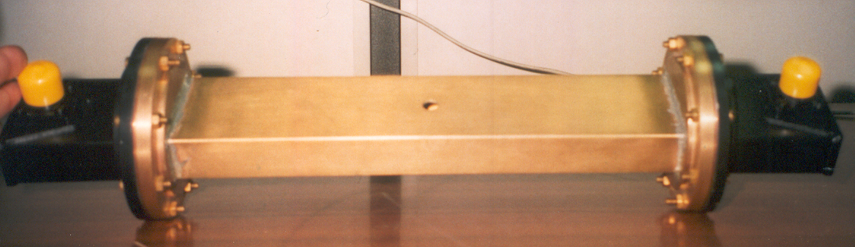 | 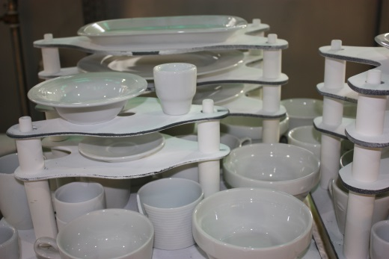
Figure- Resonant cavity for the measurement of the complex permittivity, and porcelain pieces synthesized in a high power microwave oven.

