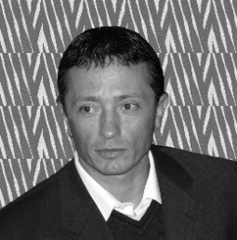
Didier Fasquelle is a Professor in the Unit of Dynamic and Structure of Molecular Materials (UDSMM) at the University of Littoral Côte d’Opale (ULCO). He is the head of the research group Functional Materials and Oxides for Applications, and the head of the master degree Electronic & Instrumentation. Didier completed his PhD at ULCO in 2003 and his state doctorate – Habilitation à Diriger des Recherches HDR – in 2012. His research interests lie in the area of lead-free oxides elaborated by different techniques, sol-gel, spin-coating, dip-coating, sputtering and screen-printing. He has developed many experiments for dielectric, piezoelectric, pyroelectric and ferroelectric characterizations. His studies and works have been dedicated to applications such as gas sensors, tunable devices, solid oxide fuel cell (SOFC), electrical energy storage (EES) and energy harvesting. He has actively collaborated with researchers in other disciplines such as materials sciences, solid-state sciences, inorganic chemistry and computer sciences, in the framework of national and international programs. Indeed he has developed collaborations with researchers from Portugal, Switzerland, Czech Republic, Ukraine, Russia, Algeria, Morocco, Tunisia, Pakistan, India and Indonesia. He has been granted for Regional, National and International projects from Foreign Affair Ministry, ANR, FEDER. Prof D. Fasquelle has co-authored around 200 papers in Peer-reviewed International journals and International communications. For his private activities, Didier is a scuba diving instructor. So he enjoys to dive all over the world. During his free-time he also likes to read books related to different subjects and cultures. He enjoys to practice Non-Violent Communication.

