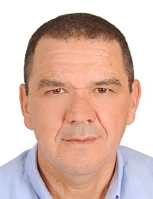 | Professor AIT ALI Mustapha is full professor at the University Cadi Ayad in Marrakech. He is working in Organic Chemistry, Organometallic Chemistry and catalysis in the Department of Chemistry, Faculty of Sciences Semlalia, Marrakech-Morocco. His research interests include Coordination Chemistry, asymmetric Catalysis, Green chemistry and the chemistry of nanostructured materials: graphene; silicene and phosphorene. Pr. AIT ALI M. was a guest professor at Villeneuve d’Ascq University, France, ENS Chimie de Rennes France and at the University of Cergy Pontoise France. He co-authored more than 100 papers published in leading refereed journals. He participated at more than 70 congress and supervised more than12 PhD students. He also participated in several international cooperation projects and he was an active member in the organization of several international conferences.

