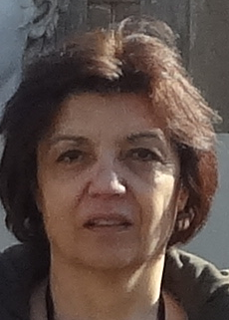
Tamara Petkova completed her PhD in physical chemistry at Central Laboratory of Optical Storage & Processing of Information of the Bulgarian Academy of Sciences. Her doctoral thesis is dedicated to new chalcogenide materials as optical storage medium. Next year after a competion she grow into Research Associate of the Institute of electrochemistry and Energy Systems -BAS. After a postdoctor scholarship at the University of Patra, Greece in the field of solid state physics, she has been promoted and currently she is full professor at Institute of electrochemistry and Energy Systems. She is Head of Materials for Energy division at IEES. The research interests include investigation of amorphous and crystalline materials for application in energy conversation and storage.

